

**STRESS METER**

A MINI PROJECT REPORT

*Submitted by*

# DHAMINI S (1NH18EC029)

*In partial fulfillment for the award of the degree of*

**BACHELOR OF ENGINEERING**

**IN**

**ELECTRONICS AND COMMUNICATION**

**NEW HORIZON COLLEGE OF ENGINEERING**

**DEPARTMENT OF ELECTRONICS AND**

**COMMUNICATION ENGINEERING**



## CERTIFICATE

Certified that the mini project work entitled “**Stress Meter**” carried out by **Dhamini S**

**(1NH18EC029)** bonafide student of Electronics and Communication Department, New Horizon College of Engineering, Bangalore.

The mini project report has been approved as it satisfies the academic requirements in respect of mini project work prescribed for the said degree.

Project guide HOD ECE

Ms Dharmambal V Dr. Sanjeev Sharma

Senior Assistant professor B. tech M. tech PhD Dept of ECE NHCE

NHCE

------------------------- --------------------

**External Viva**

Name of Examiner Signature with Date

1.

2.

ACKNOWLEDGEMENT

The satisfaction that accompany the successful completion of any task would be, but impossible without the mention of the people who made it possible, whose constant guidance and encouragement helped us succeed.

I thank **Dr. Mohan Manghnani**, Chairman of New Horizon Educational Institution, for providing necessary infrastructure and creating good environment.

I also record here the constant encouragement and facilities extended to us by **Dr. Manjunatha**, Principal, NHCE and **Dr. Sanjeev Sharma**, head of the department of Electronics and Communication Engineering. We extend sincere gratitude to them.

I sincerely acknowledge the encouragement, timely help and guidance to me by my beloved guide **Ms. Dharmambal V** to complete the project within stipulated time successfully.

Finally, a note of thanks to the teaching and non-teaching staff of electronics and communication department for their co-operation extended to me, who helped me directly or indirectly in this successful completion of mini project.

Dhamini S (1NH18EC029)

INDEX

|  |  |  |
| --- | --- | --- |
| CHAPTER NO. | CHAPTER NAME | PAGE NUMBER |
| 1 | INTRODUCTION | 8-9 |
| 2 | LITERATURE SURVEY | 10 |
| 3 | PROPOSED METHODOLOGY | 11-14 |
| 4 | PROJECT DISCRIPTION | 15-16 |
| 5 | HARDWARE  DISCRIPTION | 17 - 29 |
| 6 | RESULT | 30 |
| 7 | DISCUSSION | 31 |
| 8 | CONCLUSION | 32-33 |
| 9 | FUTURE SCOPE | 34 |

LIST OF FIGURES:

|  |  |  |  |
| --- | --- | --- | --- |
| Sl No. | Figure no. | Figure description | Page no. |
| 1 | 1(1) | Increasing stress level of the current generation | 8 |
| 2 | 3(1) | Stress meter using Arduino | 11 |
| 3 | 3(2) | Circuit representing stress meter using a transistor | 12 |
| 4 | 3(3) | Block diagram of stress meter using ICLM3915 | 13 |
| 5 | 4(1) | Circuit representing stress meter using ICLM3915 | 15 |
| 6 | 4(2) | Circuit after being built on a bread board | 16 |
| 7 | 5(1) | ICLM3915 | 18 |
| 8 | 5(2) | Pin diagram of ICLM3915 | 18 |
| 9 | 5(3) | Internal circuit diagram of ICLM3915 | 20 |
| 10 | 5(4) | A non-inverting amplifier | 21 |
| 11 | 5(5) | Internal diagram of IC741 | 22 |
| 12 | 5(6) | Male headers | 23 |
| 13 | 5(7) | A light emitting diode | 23 |
| 14 | 5(8) | Various colours of LED | 24 |
| 15 | 5(9) | A nine-volt battery | 24 |
| 16 | 5(10) | Resistor block and circuit diagram | 25 |
| 17 | 5(11) | Bread board | 27 |
| 18 | 5(12) | Potentiometer internal circuit | 28 |
| 19 | 5(13) | Potentiometer | 28 |
| 20 | 5(14) | Multimeter | 26 |
| 21 | 6(1) | The working stress meter | 30 |

LIST OF TABLES:

|  |  |  |  |
| --- | --- | --- | --- |
| Sl. No. | Table no. | Tables description | Page no. |
| 1 | 2(1) | Literature survey | 10 |
| 2 | 5(1) | Pin description of ICLM3915 | 19 |
| 3 | 5(2) | Colour coding in resistors | 26 |
| 4 | 8(1) | Stress meter readings of different people | 3 |

LIST OF ABBREVIATIONS:

|  |  |  |  |
| --- | --- | --- | --- |
| Sl. No. | Abbreviation | Abbreviated as: | Page no. |
| 1 | IC | Integrated circuit | 11 |
| 2 | ICLM | Integrated circuit linear monolithic | 11 |
| 3 | BJT | Bipolar junction transistor | 11 |
| 4 | LED | Light emitting diode | 7 |
| 5 | ZD | Zener diode | 13 |
| 6 | mA | Milli ampere | 16 |
| 7 | mW | Milli watts | 19 |
| 8 | Vout | Output voltage | 21 |
| 9 | Vin | Input voltage | 21 |
| 10 | Rf | Feedback resistance | 21 |
| 11 | Av | Gain of amplifier | 21 |
| 12 | mAh | Ampere hour | 24 |
| 13 | EEG | Electroencephalogram | 34 |

ABSTRACT

The term stress is a word which is common among every other person these days. It is that feeling that is the indication of the mental, emotional, physical tensions or strains on a human being. This quality in humans are a result of interaction between themselves and their surroundings that are understood as exceeding their capacities, straining and a threat to their wellbeing. The amount of perception signifies that the responses of humans towards stress are a reflection of the variations in personality and also variations in health or physical abilities.

This project involves the construction of a device, which is known as the stress meter. The working of the stress meter is based on the principle that the resistance of our skin changes according to our emotional states. That is resistance is inversely proportional to stress. The stress level on being high causes the skin to offer less resistance, and when relaxed resistance becomes high.

Stress meter is of great usage in today’s world the various application of stress meter include

* Usage in programs of physical fitness
* Serves as lie detector
* Muscle tension changes in person can be determined
* Mental state of the person can be determined

CHAPTER 1

INTRODUCTION

In a medical or biological context stress is a physical, mental, or emotional factor that causes bodily or mental tension. Stresses can be external (from the environment, psychological, or social situations) or internal (illness, or from a medical procedure). A survey by an NGO, Saarthak claims that among 30 companies’ 50 percent of the employees had stress in some form. So, the condition of stress is quite astounding in India. Work stress tops the list, according to surveys. Stress that's left unchecked can contribute to many health problems, such as high blood pressure, heart disease, obesity and diabetes. In order to decrease one’s stress levels he/ she must know their stress level. This device helps in identifying if the person is stressed or not. The gadget is small enough to be worn around the wrist. If the stress level is high the skin offers less resistance, and if the body is relaxed the skin resistance is high. The low resistance of the skin during high stress is due to an increase in the blood supply to the skin. This increases the permeability of the skin and hence the conductivity for electric current. This property of skin is used in this device.

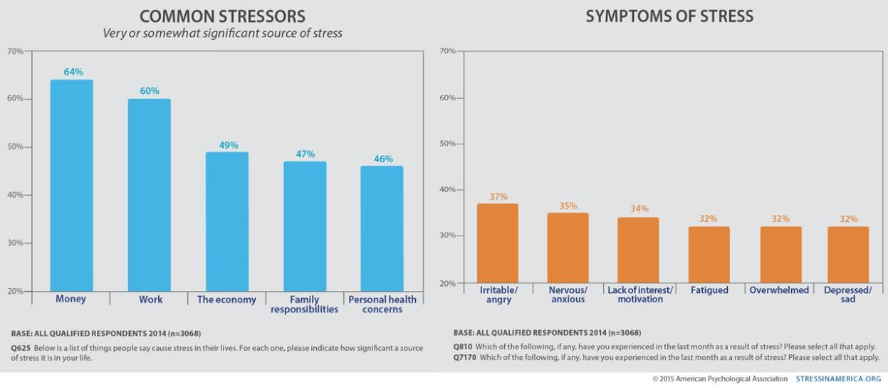

Fig-1(1): Increasing stress level of the current generation

Millennials are changing the way people look at and talk about mental health and particularly stress. It doesn’t look good to see the millennials having to put themselves into depression and stress. Being the future of our country, they shouldn’t be this stressed as it would leave a bad impact on the rest. Basically, they have work related stress. High levels of stress actually decrease work performance and the focus. Working overtime is futile, as this could affect the psychological health of the workers. The reasons behind why the millennials have more of work-related stress: difficult work life balance, unrealistic managers, deadlines and unreasonable workload. They usually stress from tech to social media overload. Surveys also point out various causes of the frustration. It can also be such as being stuck in traffic or waiting for an appointment and various other issues.

COMMON TRIGGERS OF TEEN STRESS:

Every teenager experience different kinds of stress. A survey conducted in The United States shows that there are common causes for the occurrence of stress in teenagers. A significant method to acknowledge the cause of stress and from where it develops is to indulge in conversations related to stress. It is very necessary for parents to normalize the idea of stress and encourage teens to adapt themselves to effective recovering strategies.

Lack of time management skills and pilling up of uncompleted work is a vital cause of academic stress. The aspect of social life is of high regard for teenagers and hence they tend to devote a lot of their time with their friends, bullying, subtle instances of relational aggression which becomes a major cause of teenage stress.

CHAPTER 2

### LITERATURE SURVEY

.

|  |  |  |  |
| --- | --- | --- | --- |
| PAPER  NO | TITLE | AUTHOR | OUTCOME |
| 1. | Stress and mind control | Roberto Bonomi | Visual indication of one’s stress through a light emitting diode. |
| 2. | Experimentally  Induced Stress  Validated by EMG Activity | Rosan Luijcks ,  Hermie J. Hermens, Lonneke Bodar,  Catherine J. Vossen,  Jim van. Os,  Richel Lousberg | stress accompanied by an increased level of arousal. |
| 3. | Stress meter thesis paper |  | Explains various ways of  constructing the circuit. |

Table 2(1): Literature survey

CHAPTER 3

PROPOSED METHODOLOGY

A stress detector circuit can be designed in multiple ways.

* + **Stress detector using Arduino**
  + **Stress detector using transistor (BJT)**
  + **Stress detector using ICLM3915 and IC741**

3.1 STRESS METER USING ARDUINO-UNO

In this method, the pulse sensor that is being used is used to detect the different levels of the stress. The moisture sensor of the circuit senses the sweat of the body and temperature will sense the temperature of the body. So, these 3 different sensors are clubbed to the arduino. When the stress level of the person is high, then theses three parameters of the body get affected. A buzzer is connected at the output pin. When the stress is high again then the stress is indicated by the different buzzers. Whereas, when the stress is low, only the first buzzer sound is being activated. But in case of moderate stress, then the second or the last buzzer will be activated. The hardware tools of this circuit are: arduino UNO, pulse sensor, temperature sensor and a moisture sensor. The arduino is a development board based on the ATmega328p microcontroller, which involves a lot of programming to be done as this system has to calculate the stress levels within fractions of seconds so that the user can get their stress checked up immediately or time to time.

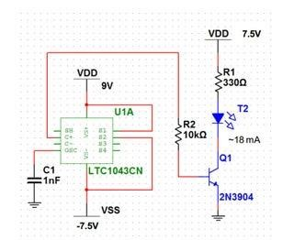

Fig 3(1): Stress meter using Arduino

3.2 STRESS METER USING TRANSISTOR

In this circuit, the input is nothing but voltage variations which are sensed by the touch pads. The touch pads used here are so sensitive that it senses even minute the voltage variation across it. The voltage variation from the pads are amplified by transistor T1. The transistor is operated in common emitter mode. The input is given to the base of the transistor. It is connected to one of the touch pads through resistor 1 and to the ground path through potentiometer VR1. This potentiometer1 controls the sensitivity of the transistor that can be adjusted to the desired level. The diode D1 here is maintained for a proper biasing of the transistor and capacitor C1 keeps the voltage from the emitter of transistor steady.

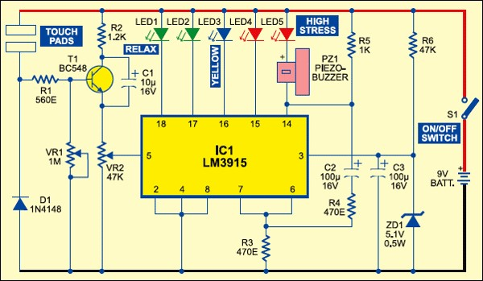

Fig-3(2): Circuit representing stress meter using a transistor

The amplified signal from transistor is given to the input of IC LM3915 through potentiometer VR2. IC LM3915 is a monolithic integrated circuit that senses voltage levels. The input is given to pin number 5 and it displays the output through the LEDs. This circuit can light up to ten LEDs. The LEDs glow with an increment of 125 mV in the input i.e. the last LED glows when a current of 650mA is supplied. A total of five LEDs are used. Which are connected at pins 14 through 18 of IC. Resistors R4 and R5 and capacitor C2 combine to form the flashing elements. Resistor R3 maintains the LED current at around 20 mA. Capacitor C3 should be placed close to pin 3 for proper functioning of the IC. Zener diode ZD1 in series with resistor R6 provides regulated 5V to the circuit. A piezo buzzer is used to indicate high stress levels.

Out of all these methods the chosen and the proposed method is:

3.3 STRESS METER USING ICLM3915 AND IC741

In this method two ICs are used. One for amplification and the other for sensing voltage variations. The input is given to the touch pads. The touch pads are nothing but a pair of metal contacts. The voltage variations detected in this stage are amplified by the IC741, this IC is a non-inverting amplifier. The gain is maintained to be 2. This achieved by varying the value of the feedback resistance Rf. Thus, the voltage leaving the IC will be two times the input. The output of IC741 is now connected to the input pin of ICLM3915. The input pin of ICLM3915 is pin number 5. The block diagram of the device described here is as follows

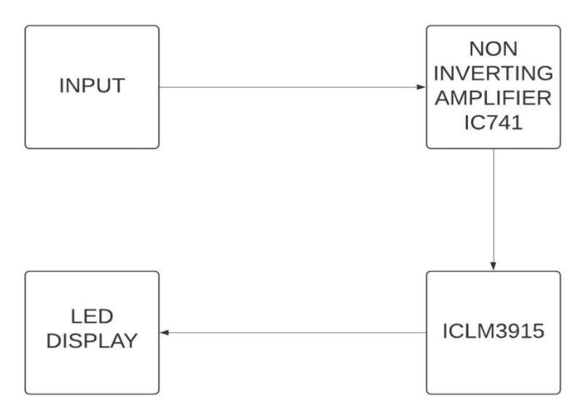

Fig-3(3): Block diagram of stress meter using ICLM3915

Reason for choosing the method which involves ICLM3915 an IC741 is

1. Easy to build the circuit
2. Less circuit elements
3. Easy testing and debugging
4. Easy output analysis

CHAPTER 4

PROJECT DESCRIPTION

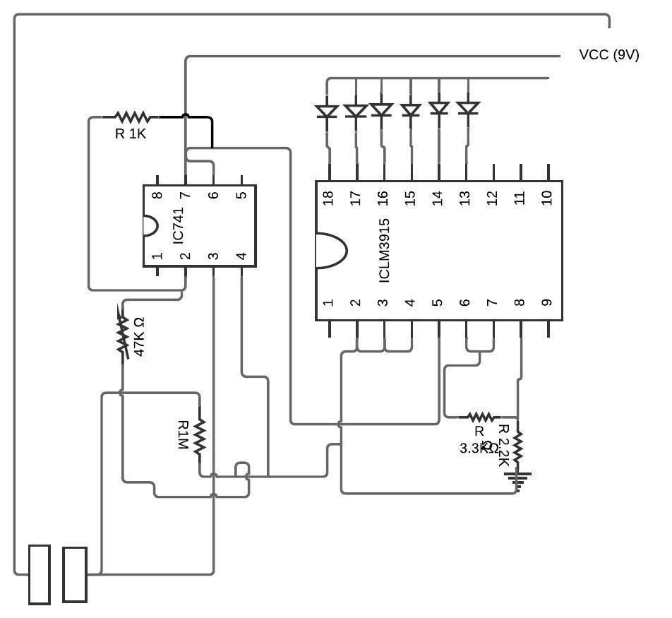

Fig 4(1): Circuit representing stress meter using ICLM3915

* 1. WORKING PRINCIPLE:

The resistance of the skin varies in accordance with one’s emotional states. If the stress level is high the skin offers less resistance, and if the body is relaxed the skin resistance is high. The low resistance of the skin during high stress is due to an increase in the blood supply to the skin. This increases the permeability of the skin and hence the conductivity for electric current.

* 1. CIRCUIT EXPLANATION:

The input to this device is the voltage variations that the touchpads sense. The touch pads are highly sensitive to voltage variation and detects even a minute voltage variation across the touch pads. The question now is how are these voltage variations related to the stress of an individual. If an individual is under high stress the resistance offered by the individual’s body is less, thus less voltage drop is observed across the body which results in high voltage across the touch pads. The voltage variations from the touch pads are amplified by IC741 which is a non-inverting amplifier operated with the gain 2 which is achieved by maintaining the feedback resistance Rf and input resistance Ri equal. The sensitivity of the device is directly related to the gain of the amplifier. If the value of the feedback resistance is not appropriate the output obtained is not accurate. The desired value of the feedback resistance is obtained by using a potentiometer (variable resistance). By tuning the potentiometer, the desired value of feedback resistance is set. The output of IC741 which is obtained at pin number 6 which is the amplified value of the voltage variation. This amplified signal is now fed to the input of the IC LM3915. The function of this IC is that it detects the amount of voltage entering the IC. The LED connected to pin 13 indicates high stress level and the LED connected to pin 18 indicates low stress. Discussing in terms of the current delivered to each LED; the amount of current required to drive the LED at pin 18 is 150mA and the current required to drive LED at pin 13 is 800mA.

The circuit after being built looks like:

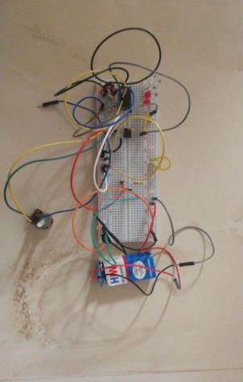

Fig4(1): Circuit after being built on a bread board

CHAPTER 5

HARDWARE DESCRIPTION

The following components have been used to build this circuit.

1. Resistor R1 (2.2k ohms)
2. Resistor R2 (3.3k ohms)
3. Resistor R3 (1M ohm)
4. Resistor Rf (1k ohm)
5. Potentiometer (47k ohm)
6. ICLM3915
7. IC741
8. LED1 and LED 2 - colour green
9. LED3 and LED 4- colour blue
10. LED5 and LED 6-color red
11. Touch Pads (metal contacts)
12. Power supply (9V)
13. Jumper wires
14. Bread board
15. Multimeter (for testing)

A detailed explanation about these elements are given as follows for better understanding of the circuit.

5.1 THE MONOLITHIC INTEGRATED CIRCUIT:

IC number: ICLM3915

This senses analog voltage levels. The input is given at its pin 5. The output can be seen from pins 18 to 10 and pin 1. The LEDs connected across these pins glow in accordance with the input thus providing a logarithmic analog display. This IC can drive up to ten LEDs one by one in two modes namely dot mode and bar mode. A minimum of 125mA of current is required for the first LED to glow, the adjoining LEDs glow with an increment of 125mA. This device used Only six LEDs are connected from pin 13 to 18 of IC1. LED1 glows when input pin 5 of IC1 receives 150 mA. LED6 glows when the voltage rises to 800 mA and LED6 flashes when the stress level is very high.

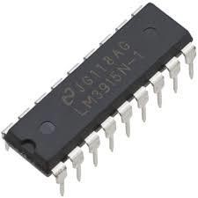

Fig 5(1): ICLM3915

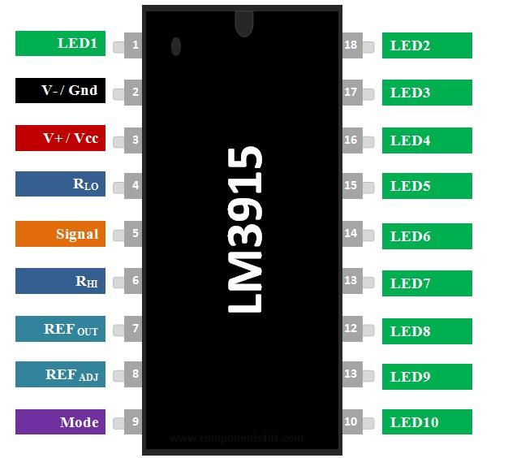

Fig 5(2): Pin diagram of ICLM3915

The Maximum rating of the IC are listed below.

Supply Voltage = 25V

Output Supply on the LEDs if you are using a separate supply here = 25V (same as above)

Maximum Input Signal Range = +/-35V

Divider Reference Voltage = -100mV to Supply Level.

Power Dissipation = 1365 mW

5.11 PIN DISCRIPTION:

|  |  |  |
| --- | --- | --- |
| PIN  NUMBER | NAME OF THE  PIN | FUNCTION OF THE PIN |
| 1 and 10 to  18 | LED1, LED2, LED3....LED10 | The 10 LEDs which has to be controlled is connected to  these pins |
| 2 | V- / Ground | Ground pin |
| 3 | V+ / Vcc | Supply Voltage (5-18) V |
| 4 | RLO | Low level voltage |
| 5 | SIGNAL | signal Input |
| 6 | RHI | High Level voltage |
| 7 | REF OUT | Output Reference Voltage |
| 8 | REF ADJ | Adjust pin |
| 9 | Mode | Select between Dot/Bar Mode |

Table 5(1): pin description of ICLM3915

5.12 INTERNAL CIRCUIT DIAGRAM:

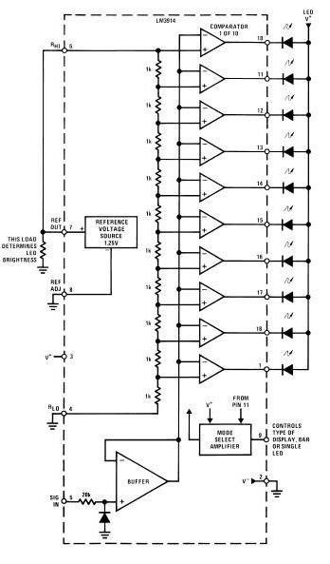

Fig 5(3): Internal circuit diagram of ICLM3915

5.2 THE NON-INVERTING AMPLIFIER:

IC number: IC741

A non-inverting amplifier is an op-amp circuit configuration which produces an amplified output signal. This output signal of non-inverting op amp is in-phase with the input signal applied that is there is 0 degrees phase shift. The gain equation of a noninverting amplifier can be derived as follows

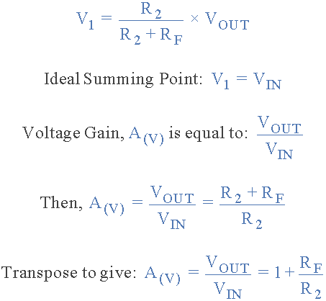

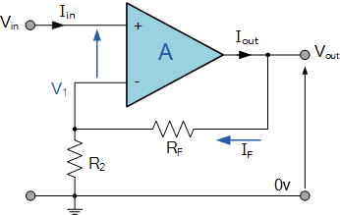

Fig 5(4): A non-inverting amplifier

From the equation of Av, it is understood that the gain is always greater than 1

5.21 THE INTERNAL CIRCUIT DIAGRAM:

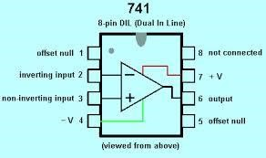

Fig 5(4): Internal diagram of IC741

1. Offset Null - Rarely used. It can be used to adjust for small errors in the two inputs so zero volts in gives zero volts out.
2. Inverting Input - If this voltage goes up, the output voltage will go DOWN unless the Op Amp is already saturated.
3. Non-Inverting Input - If this voltage goes up, the output voltage will go UP unless the Op Amp is already saturated.
4. The minus supply - Sometimes this is connected to zero volts (ground).

Sometimes it's connected to a voltage between -5V and -18V or more for a few specialised op amps.

1. Offset Null - Rarely used. It can be used to adjust for small errors in the two inputs so zero volts in gives zero volts out.
2. The Output - In an ideal Op Amp, the maximum and minimum output voltage is equal to the power supply voltages. In a real-life Op Amp, these voltages are 2 to 3 Volts less.
3. The plus supply - Voltages from +5V to +18V are common. There are specialist and more expensive Op Amps with a higher voltage rating.
4. No Connection - This pin is not used.
   1. THE INPUT TERMINALS:

Touch pads act as the input acceptors. They are nothing but a pair of metallic material. The touch pads of the stress meter sense the voltage drop or voltage variations across the pair of touch pads and convey the same to the device

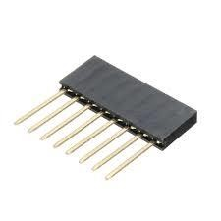

Fig 5(6): male headers

* 1. LIGHT EMITTING DIODE (LED):

A light-emitting diode (LED) is a semiconductor light source that emits light when current flows through it. Electrons in the semiconductor recombine with electron holes, releasing energy in the form of photons. The voltage drop across the LED is 2V and it can carry a current of 18mA without damaging. 6 LEDs are used in this device. 3 different colours are used for better identification of stress levels. Green LED indicates low stress, blue LED indicates moderate stress and red LED indicates high stress. 2 LEDs of each colour is used to obtain accurate result.



Fig 5(7): A light emitting diode

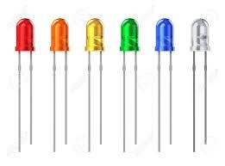

Fig 5(8): Various colours of LED

5.5 THE POWER SUPPLY:

A 9-volt battery is used to power up the circuit. The battery has both terminals in a snap connector on one end. The smaller circular (male) terminal is positive, and the larger hexagonal or octagonal (female) terminal is the negative contact. The battery used here is an alkaline battery. A circuit that draws 10mA powered by a 9V rectangular battery will operate about 50 hours: 500mAh/10mA=50hours. The cell voltage of alkaline cells steadily drops with usage from 1.54 volts to about 1 volt when discharged. The voltage is near 1.25 volts at 50% discharge point.

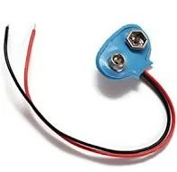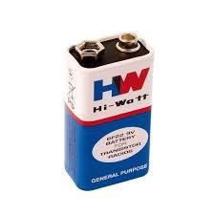

Fig 5(9): A nine-volt battery

5.6 RESISTORS:

Resistors used in this device are 2.2k, 3.3k,1k and 1M. Resistors are passive two-terminal electrical component that implements electrical resistance as a circuit element. In electronic circuits, resistors are used to reduce current flow, adjust signal levels, to divide voltages, bias active elements, and terminate transmission lines, among other uses. Resistors are what are called “Passive Devices”, that is they contain no source of power or amplification but only attenuate or reduce the voltage or current signal passing through them. This attenuation results in electrical energy being lost in the form of heat as the resistor resists the flow of electrons through it. Colour coding is used in resistors to calculate the magnitude of the resistance in ohms.

The colour code for 1k ohm will be: Brown, Black, Red, Gold

The colour code for 2.2k ohm will be: Red, Red, Red, Gold

The colour code for 3.3k ohm will be: Orange, Orange, Red, Gold

The colour code for 1M ohm will be: Brown, Black, Green, Gold

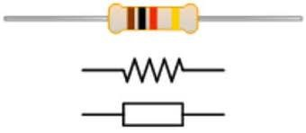

Fig 5(10): Resistor block and circuit diagram

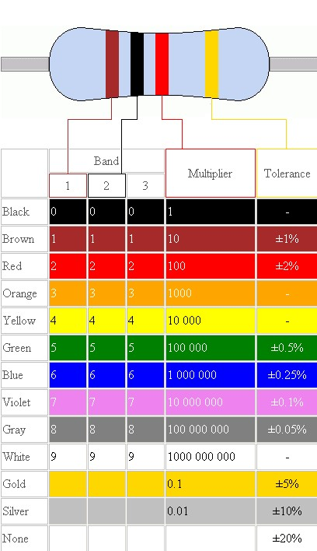

Table 5(1): colour coding in resistors

Colour coding is a process widely used in determining the values of the resistors. The colour bands on the resistor are of utmost significance while determining the value of the resistors. Each colour has a resistance value along with a tolerance value as shown in the figure 5(1) mentioned above.

5.7 BREADBOARD:

A breadboard is a solderless device for temporary prototype with electronics and test circuit designs. Most electronic components in electronic circuits can be interconnected by inserting their leads or terminals into the holes.

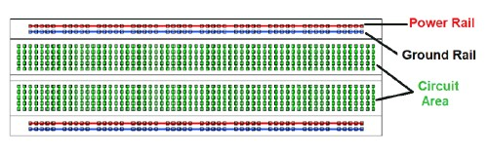

Fig-5(11): bread board

The holes covered by the green line are shorted. A pair of possitive and negitive supply lines are provided for easy connections. A bread board hepls in hassel free connection of curcuit elements.

5.8 JUMPER WIRES:

A jumper wire is an electrical wire with a connector or pin at each end which is normally used to interconnect the components of a breadboard or other prototype or test circuit, internally or with other equipment or components, without soldering. Individual jump wires are fitted by inserting their "end connectors" into the slots provided in a breadboard, the header connector of a circuit board, or a piece of test equipment.

The types of jumper wires are

The jumper wires are typically of three types:

The difference between the three types are based on their end of the wire. Basically, the male tip has a protruding end which is used to plug into things whereas, the females do not have protruding ends and cannot be used to plug into things.

▪ The male-to-male:

This is the most common type of jumper wire that is being used often. Our project also involves the use of this type of jumper wires. Especially while connecting two ports on a breadboard a male-to-male wire is useful.

Male-to-female:

The male to female jumper wire is useful in connecting female header pin of any board to a development board having a male connector.

1. Female-to-female:

This jumper wire is very much handy for making wire hardness on PCB’s.

5.9 POTENTIOMETER:

A potentiometer is a device with which the resistance can be adjusted. A potentiometer has the two terminals of the input source fixed to the end of the resistor. To adjust the output voltage the sliding contact gets moved along the resistor on the output side.

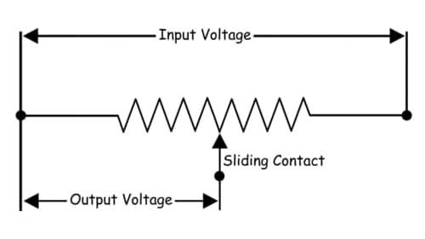

Fig 5(12): Potentiometer internal circuit

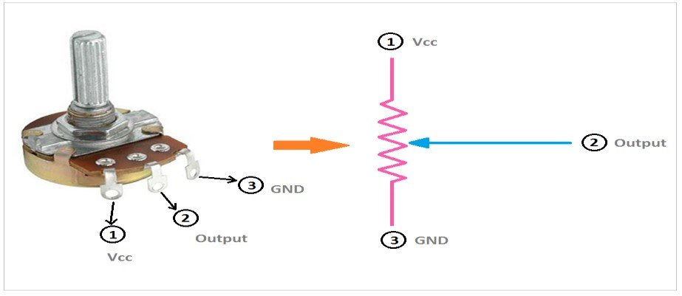

Fig 5(13): Potentiometer

5.10 MULTIMETER**:**

A multimeter is an electronic device that combines various measurement functions in a single unit. It basically measures voltage, current and resistance. In an analog multimeter, it uses a microammeter with a moving pointer to display the reading. Whereas for a digital multimeter it has a numeric display and can also show a graphical bar that represents the value that has been measured. A multimeter is useful for basic fault finding or in another way, an instrument which can measure a very high degree of accuracy.

When it is used for measuring voltage, the input impedance should be very high when it is being compared to the impedance of the circuit that is measured. Or else the circuit operation might get changed and then reading the measured value will be totally inaccurate.

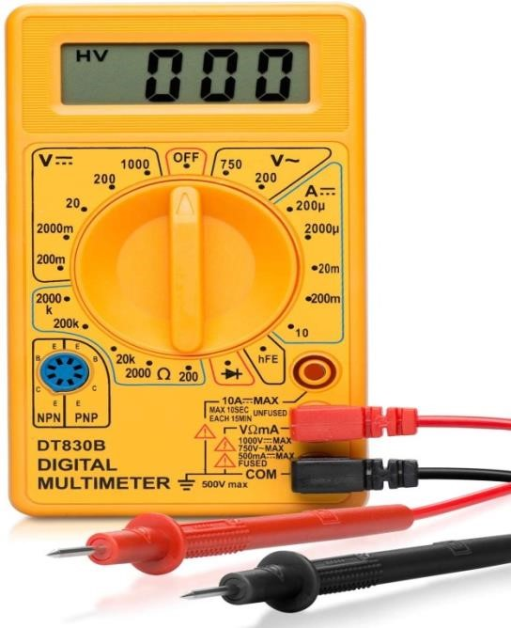

Fig 5(14): multimeter

CHAPTER 6

RESULT

The result of this project was demonstrated successfully. By testing it on people like: check the stress of a person before and after a jog and even after a stressful day.

This project’s goal was to design a stress level indicator kit that allows you access your emotional pain. We have given our full efforts to make this mini project a successful biomedical device.

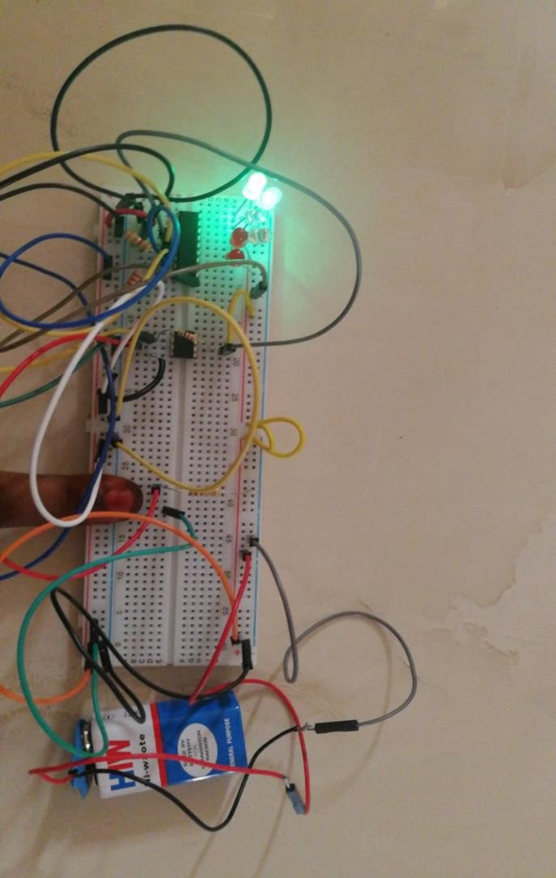

Fig 6(1): the working stress meter

CHAPTER 7

DISCUSSION

Our results clearly show that the stress meter is a valid and effective measure of stress. We have successfully designed a measure of stress that is easy to administer using stress meter is not burdensome or annoying for users, and can effectively produce a valid real-time measure of stress in natural environments.

The main part of this study involved the design of a device which is able to detect skin resistance in different situations. It also includes an initial threshold between being stressed and being relaxed, but it is not the algorithm that is going to be implemented in the final application. it can be observed that signals increase or decrease depending on the effort or the mental situation of the user. The main problem is that, for the moment, we cannot differentiate being stressed from making an effort. This is clearly seen where a laugh presents a similar response to feeling stressed.

CHAPTER 8

CONCLUSION

By inference, the procedure was considered as satisfactory and was demonstrated successfully. A considerable amount of random variations was also present in the results.

This project demonstrates the determination of the stress of the person by the measurement of the resistance of the skin. When the person places his finger upon the conducting wires (touch pads) this drives the LEDs to glow accordingly according to his stress levels.

ADVANTAGES

1. Portable
2. Low power consumption
3. Low cost
4. Highly sensitive to small currents
5. Simple circuit
6. Easy to use
7. It can be used in physical fitness programs

DISADVANTAGES

1. Less accuracy
2. Output is not measurable

TESTING OF THE DEVICE:

The device was tested on multiple individuals after various activities. The findings are listed below.

|  |  |  |  |
| --- | --- | --- | --- |
| LED NO. | LED COLOUR | STRESS LEVEL | CAUSE OF STRESS LEVEL OF A PERSON |
| 1 | GREEN | Very low stress | A person after meditation was very  calm |
| 1 | GREEN | Very low stress | A person who just woke up |
| 2 | GREEN | Moderately low stress | A person after a relaxed walk. |
| 3 | BLUE | Moderate stress | A person suffering from insomnia |
| 3 | BLUE | Moderate stress | A student preparing for exam |
| 4 | BLUE | Tolerable stress | A person in the influence of alcohol. |
| 5 | RED | Moderately high stress | A student before writing an exam. |
| 6 | RED | Very high stress | A person after a marathon or the person overthinking. |
| 6 | RED | Very high stress | A person under depression. |

Table 8(1): stress meter readings of different people

CHAPTER 9

FUTURE SCOPE

An emotional stress meter using skin resistance and conductance is a basic model to determine stress and emotional change of a person. This device can be further developed to design equipment like lie detectors, skin response meters; mental fitness meters etc. therefore this model, if further developed can be used in medical field, with sportsperson, forensic department and it even helps in improving the body fitness. And it could be better to combine this device with EEG as wireless and which will calculate both the result and indicate level of stress in a person.

REFERENCES

1. Roberto Bonomi, “stress and mind control”, dated 21/03/2008
2. Richard (Jaegar and Travis 7) laloc +s, “micro electronic circuit design, Third Edition Errata, 0112
3. Loggia, M. L.; Juneau, M. N.; Bushnell, M. C. (2011). "Autonomic responses to heat pain: Heart rate, skin conductance, and their relation to verbal ratings and stimulus intensity". *Pain*. 152 (3): 592–598.
4. IEEE papers referred to myieee.org
5. Operational Amplifier and Linear Integrated Circuits, by R.F. Coughlin and Fredrick.